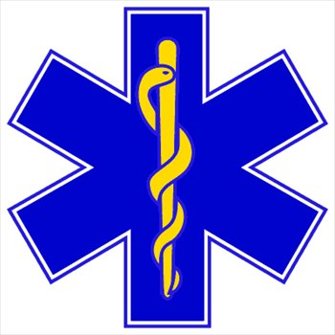

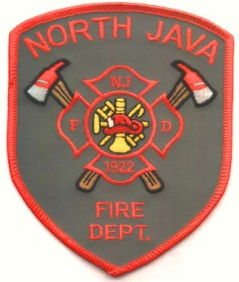***North Java Fire Department***

*4274 Route 98*

*North Java, NY  14113*

*Phone: (585) 535-9950*

## Application for Membership

Name (First)____________________(Middle)___________________ (Last)________________________ Maiden:___________________________ Phone(_____)__________________

Address:______________________________________________________________________

City:_____________________________ State: ______ Zip:______________________

Social Security Number: ________-______-_____________

Age:________ Date of Birth:___/____/________ Place of Birth: ____________________

Level of Education (Circle One) High School Some College Associates Bachelors

Area of Interest: EMS________Fire Service_______ Both________Social______

List all Fire Training:(Provide Copies) __________________________________________________________ ______________________________________________________________________________________________________________________________________________________________________________________________________________________________________________________________________________

Drivers License I.D. Number: _______-_______-_________ Class: _________

Expiration Date:____________

References: 1)_______________________________ Phone(______)_________________

2)_______________________________ Phone(______)_________________

Employer:____________________________________ Phone(______)_________________

Address:________________________________________________

City, State:________________________________________ Zip:____________

Occupation/Title:__________________________ Shift:_____________________

Your attendance at monthly meetings, drills, work nights, rescue squad meetings (if certified) and fund raising activities is expected.

Please submit a $5 non-refundable filing fee and $10 dues to:

Secretary, North Java Fire Co., Inc.

4274 Route 98, North Java, NY. 14113

I hereby give the North Java Fire Co. permission to do a background check on myself as a prospective new member. I also attest that all the above information is accurate and true to the best of my knowledge.

_______________________________

Applicant’s Signature

_______________________________

Parent/Guardian Signature

*If applicant is under age 18

*In signing this application, the parent/guardian agrees to accept the responsibility of making sure the applicant obtains the necessary training required to become a member of the North Java Fire Co.

*The sponsor shall be responsible for making sure the new member adheres to the rule and regulations set forth in the By-Laws of the North Java Fire Company.

__________________________

Sponsor’s name

__________________________

Sponsor’s Signature

*Female applicants note: If you become pregnant while a member, you are **required** to notify your chief immediately. Upon such notification you must file paperwork through the county witch in turn your duties may be limited. This is for the well being of you and your child.

*Any falsification on this application will be grounds for Article XII per the By-Laws.

List any felonies within last 5 years:

Description:__________________________________________Year:__________

Description:__________________________________________Year:__________

Description:__________________________________________Year:__________